**Editing Symba Doc**

This document contains the basics for html and how to edit the SyMBA doc.

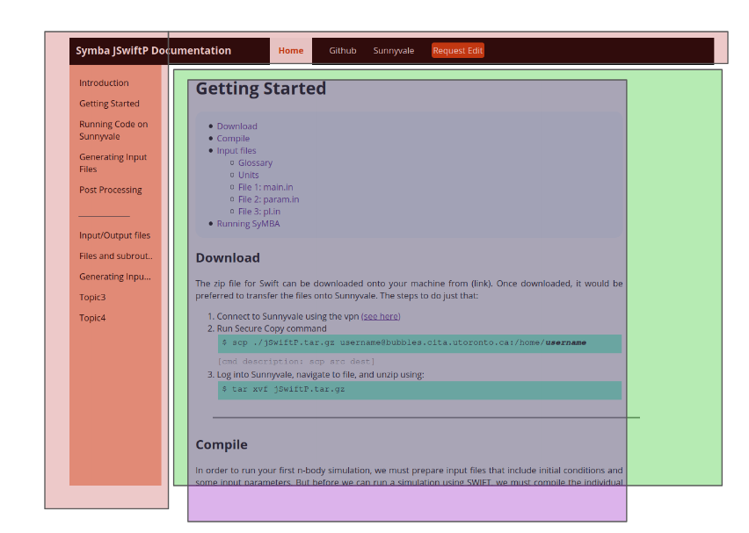

Steps:

1. Type up the new page on word
2. Make edits to navbar
3. Create a new *-page.html and *-content.html files
4. Add content using the style classes below to make the page look nice

Resources:

<https://www.youtube.com/watch?v=SDL4am7qNjU>

<https://github.com/Maninder-sd/SyMBA-doc>

<https://maninder-sd.github.io/SyMBA-doc/pages/introduction-page.html>

**Style classes**

| **Class** | **Description** |
| --- | --- |
| span.i | italics |
| span.b | bold |
| div.break | Break line |
| div.cmd | Block command env. |
| span.ilcmd | In-line command env. |
|  |  |
| div.name | Name of file |
| div.file | File environment |
| div.file.dense | Smaller font |
|  |  |
| ul.#CONTENTS | Table of contents |

**Useful HTML tags**

| <br> <br> | Break line |
| --- | --- |
| <h1>Header</h1> | Make header |
| <a href="google.com"> link</a> | Hyper link |
| <ul>  <li>item 1</li>  </ul> | List |
| <ol>  <li>item 1</li>  </ol> | Numbered list |